**The Little Ice Age**

1. **Read an Analyze the scenario**

**Scenario:** The little ice age started in the 14th century and lasted until the 19th century. During this time the temperatures decreased and many rivers and seas froze over. We are given evidence of the cold through paintings where they show the lakes frozen over in areas where today, the lakes rarely freeze over. I am sure that if we looked at novels from that time we would also be able to find evidence of the little ice age.

**Situation:** The International Commission on Economics (ICE) wants us to research where they should invest funds to grow crops where the climate is more likely to be stable. This would entail looking at past climate records of the areas and also where the greatest portion of the worlds crops are grown. We would need to combine the two by hypothesizing what should happen to these areas based on past climate records, and predictions for what could be happening in cycles such as sunspots, oceanic cycles, and also rotation around the sun cycles.

1. **The groups ideas and hunches**

* The Little Ice Age was due to a combination of natural occurrences in the Earth (Ashley)
* Lower sunspot activity would cause a cooling of the earth, however we cannot determine if at the beginning there was less sunspots since the recording of them did not start until the 1600’s. (Brittany, Ashley and Brad)
* The Little Ice Age may have been influenced by both the lack of sunspots and the oscillation of the Earth (Ashley)
* There are both historical and scientific recordings proving the coldness of the era. (Ashley)
* Enhanced volcanic activity could cause a decrease in the earth’s temperature by putting up ash in the air. (Brittany)
* Water currents could also affect the temperatures of the water and on land. (Brittany)
* Crops suffer from abnormal temperatures and people suffer when they don’t have access to food (Maile)
* The temperatures of water, land, and air affect each other (Maile)
* Does this have to do with the Milankovitch theory of cycles? (Maile)
* Climate records have been slowly rising since the Little Ice Age (Matt).
* Ice caps have been melting (Matt)
* There has been a decrease in sunspots (Matt).
* The sea temperatures have been increasing (Matt).
* Most of the world’s staple food’s come from the United States and South America (Matt).
* If something similar to the LIA occurred we would have to make sure our crops were not being harvested in places that have an extreme change in harvest temperature (Matt).
* There may be a circular pattern in the Earth’s warming and cooling as we spin around our sun on a pivotal access (Brad).
* There is a humanistic effect to the climate change as well as a natural one (Brad).
* The Little Ice Age damaged cultivations and food productivity, which may have caused a more nomadic lifestyle (Brad).

1. **List what is known (Research)**

**Evidence of the Little Ice Age**

There is evidence of the Little Ice Age from many sources, some scientific and some artistic. Paintings done in the Little Ice Age show the different climate that was present at that time. During the 17th and 18th centuries there are historical accounts of the glaciers advancing beyond previous historical limits. The Little Ice Age also affected the daily life of people living in the Northern Hemisphere. For example, it has been blamed for the demise of the Norse settlements in Greenland. The Little Ice Age created problems for fisherman in Iceland, Scandinavia, and the Norse settlements in Greenland, which could have contributed to their demise.

The people living in the northern hemisphere were also affected by disease. The cool and wet summers led to the St. Anthony’s fire illness where whole villages would get ill with convulsions, hallucinations, gangrenous rotting of the extremities and death. The Black Death also happened during the Little Ice Age. In parts of England, outbreaks of Malaria were seen that caused illness and death.

Scientific evidence for the Little Ice Age is found in temperature records from that time. Scientists have also examined ice cores, which are measured directly from the tiny bubbles trapped in ice cores. Scientists measure the ratio of oxygen and hydrogen isotopes against a standard (Standard Mean Ocean Water). For periods where there is a colder climate, there is less O18 because more energy is used to evaporate a water molecule containing the heavier isotope and is instead lost in precipitation. This method of using ice cores to determine the climate has been used to look at the past 100,000 years. During that time there have been seven ice ages, and each one was between a warm climate.

<http://www.atmos.washington.edu/1998Q4/211/project2/group4.htm>

<http://www.scientificamerican.com/article.cfm?id=how-are-past-temperatures>

<http://holocene.meteo.psu.edu/shared/articles/littleiceage.pdf>

<http://www2.sunysuffolk.edu/mandias/lia/little_ice_age.html>

**Possible Causes of the Little Ice Age**

**Solar Activity**

**What Are Sunspots?** Sunspots are dark spots on the surface of the sun where intense magnetic activity takes place, causing occasional ferocious eruptions of electrified gas and light on the surface of the sun. Sunspots prevent hot gasses from escaping the interior and reaching the surface. The overall effect of sunspots is a positive one, where the sun emits more light that warms the climate of earth. More sunspots usually mean an increase in solar activity. The disappearance of sunspots makes the sun cooler. When the sunspots are at a minimum, the sun expands and its rotation is slowed down.

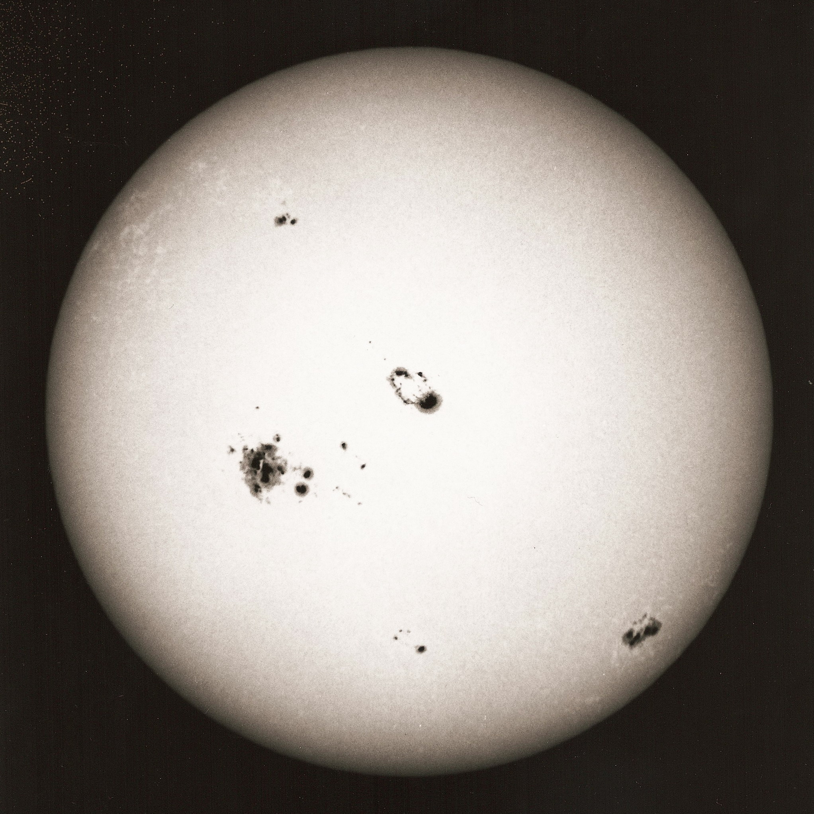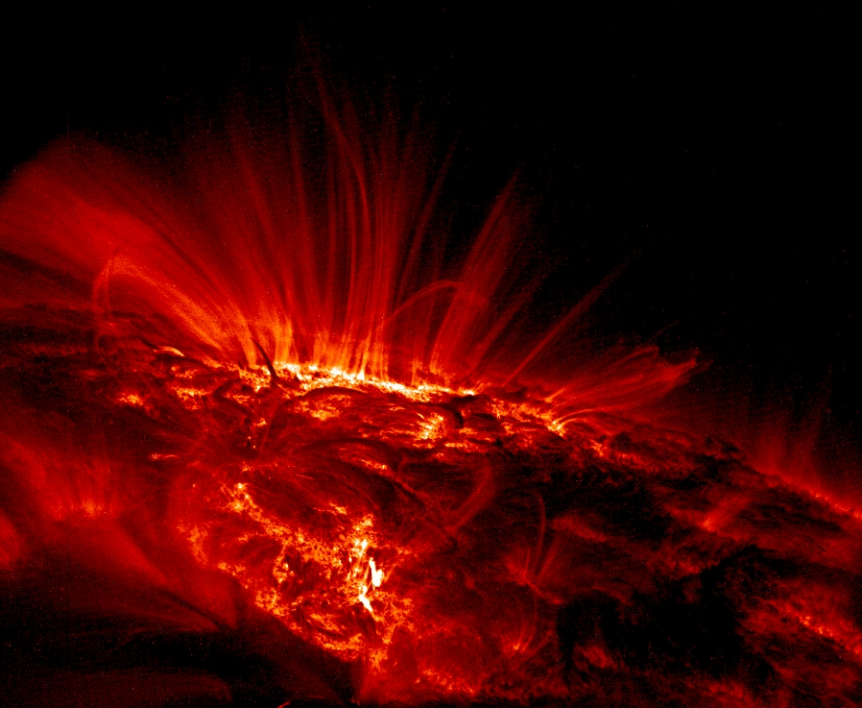

<http://www.eh-resources.org/timeline/timeline_lia.html#maunder> <http://arstechnica.com/science/news/2009/08/another-little-ice-age-solar-activity-and-climate-change.ars><http://www.space.com/scienceastronomy/sunspot_record_041027.html>

**How did sunspots play a role in the little ice age?** Although there is no official cause of the LIA, many scientists speculate that it was due mostly in part to low sunspot activity. The Maunder Minimum was at its height from 1645 to 1715.Sunspots could be seen by the astronomers of the day, such as Galileo with his invention of the telescope in 1610. The Maunder Minimum caused a colder sun which also meant the sun would send out less warmth to the earth. Cooling the climate and affecting oceanic oscillations. During one thirty year time span inside of the LIA astronomers observed about only fifty sunspots on the sun, astronomers today are viewing forty to fifty thousand sun spots. During the Little Ice Age the sun dropped in temperature by about ¼ of a percent

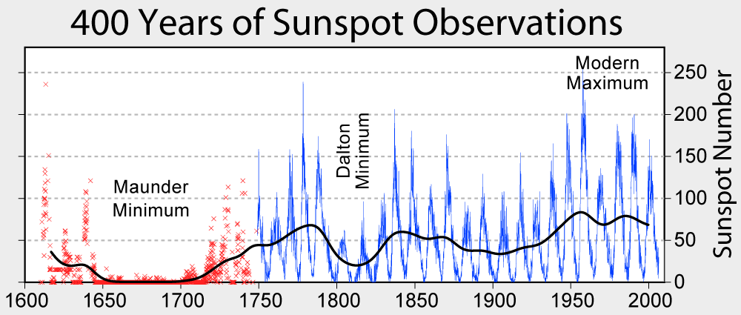

<http://www.eh-resources.org/timeline/timeline_lia.html> <http://www.atmos.washington.edu/1998Q4/211/project2/group4.htm>

**Volcanic Activity**

During the Little Ice Age, there was a period of increased volcanic activity. In 1815, Tambora erupted in Indonesia in one of the largest eruptions in history. The eruption created columns of volcanic materials that reached 40km in the sky, and put over 200 million tons of sulfur dioxide gas into the stratosphere. The sulfur dioxide limits the amount of sunlight that reaches the earth and can cause cooling of the earth globally. This eruption was the likely cause of the “year without a summer” (1816) in which snow was still falling until June.

In 1835, Coseguina in Nicaragua erupted which again sent sulfur dioxide into the air. This large eruption could have contributed to the fact that the late 1830’s were very cold. In August 1883, Krakatau in Indonesia also erupted. This was a strong explosion that again put lots of ash into the air; this could also have affected the weather near the end of the Little Ice Age.

Volcanic activity could have contributed to the Little Ice Age, but was not the cause of the Little Ice Age. This is because the major eruptions happened in 1816, 1835, and 1883, while the Little Ice Age began in the 14th century. Although the volcanic activity may have contributed to the severity of the Little Ice Age, for example the Tambora eruption was followed by the year without a summer. 1838 was the coldest year of the Little Ice Age and was preceded by the Coseguina eruption in 1835.

<http://www.bbc.co.uk/dna/h2g2/A781715>

<http://vulcan.wr.usgs.gov/Volcanoes/Indonesia/description_krakatau_1883_eruption.html>

**Surface Albedo**

The light that the Sun produces can either be absorbed or reflected on earth. The albedo is the fraction of solar radiation that is reflected back into space from the Earth. A surface albedo of zero means that all of the sunlight is absorbed at the surface and none of the sunlight is reflected back into the atmosphere. ‘A surface albedo of one’ means that all sunlight is reflected from the surface back into the atmosphere. Snow has a surface albedo close to one and deep clean ocean water has an albedo close to zero. During the Little Ice Age there was more snow and ice, which reflect the sun’s light. This decreases the sun’s radiant energy that reaches the surface of the earth and leads to additional cooling. Although the surface albedo would not have initially caused the Little Ice Age, it could have contributed to the extended length of the period.

The surface albedo would not have caused the Little Ice Age because it reacts in a negative feedback mechanism. When there is more ice and snow, and therefore colder then more of the sun’s radiant is reflected back into the atmosphere and the earth becomes colder. Once more ice and snow accumulated then the surface albedo would contribute to the severity of the Little Ice Age.

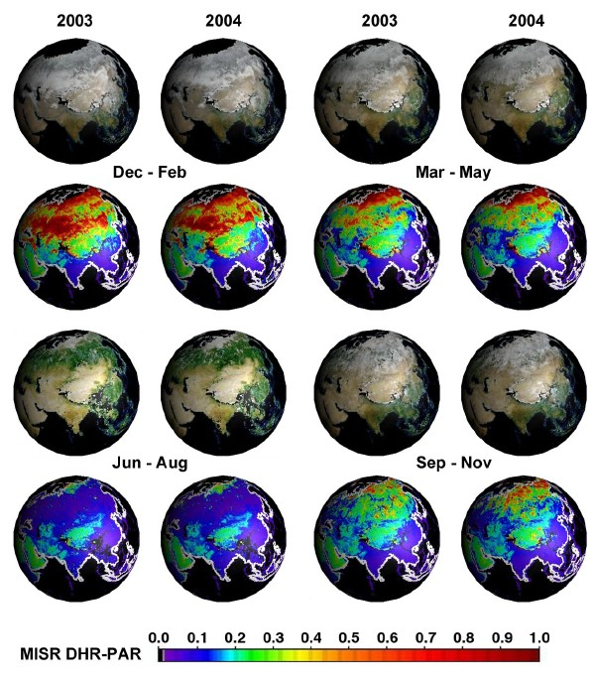

http://www2.hawaii.edu/~jmaurer/albedo/

<http://eosweb.larc.nasa.gov/HPDOCS/misr/misr_html/global_seasonal_albedo.html>

**Milankovitch Theory**

The Milankovitch Theory says that there are different cycles of the elliptical activity of the earth circling the sun and these affects may alter the climate we experience. Eccentricity is the cycle focusing on the shape of the elliptical path of the sun. It varies from more elliptical to less elliptical and has a periodicity of 100,000 years. The eccentricity affects the climate because it changes the distance that the sun’s short wave radiation must travel. The Earth receives about 20-30% more energy when the path is the most elliptical at its closest point than at its farthest point. This would produce extreme changes in the climate.

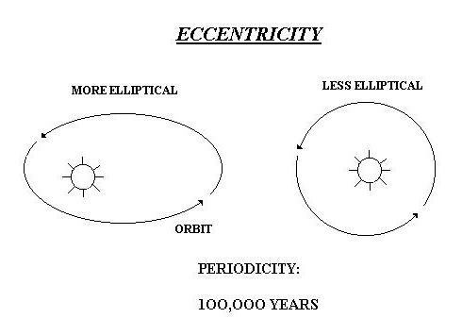

The Axial tilt also influences the climate. The axial tilt cycles between 21.5 and 24.5 every 41,000 years. When the axial tilt is smaller than the Sun’s solar radiation is more evenly distributed. This would cause colder summers and warmer winters. However because of the warmer winter air, it would hold more moisture and would produce a greater amount of snowfall. Since the summers are colder less snow is melted.

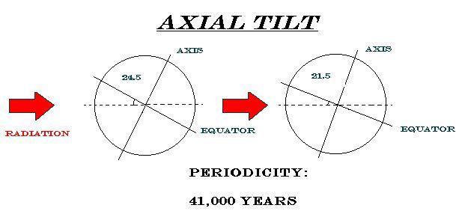

Precession has a periodicity of 23,000 years and is the earth’s slow wobble as it spins on its axis. Precession influences when the Earth will feel the summer and winter. For example, when the axis is tilted toward Vega positions of the Northern Hemisphere than winter will be experienced when the Earth is furthest from the Sun and summer when the Earth is closes to the Sun.

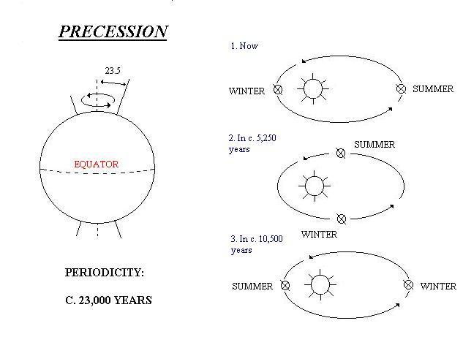

The Milankovitch theory would not have been the cause of the Little Ice Age because they act on a slow scale. It causes slow changes from warm to cold. The Little Ice Age was preceded immediately by the Warm Medieval Period, and there was not intermediate period between the two. Therefore, it is unlikely the cause of the Little Ice Age could be attributed to the Milankovitch theory.

<http://www.homepage.montana.edu/~geol445/hyperglac/time1/milankov.htm>

**Ocean-Atmosphere Conveyor System**

The most volatile region of the Earth’s climate lies in the North Atlantic Region between the Subtropical region of Central America and the Polar Regions of northern Europe and Asia. The extreme, and often unpredictable, vulnerability is caused by a complex interaction between the atmosphere and the ocean. The main feature of this is the North Atlantic Oscillation (NAO), a seesaw between a persistent high of atmospheric pressure over the Azores and an equally persistent low over Iceland. This is the usual, pattern, called a Positive NAO Index, which brings mild, humid air to Northwest Europe.

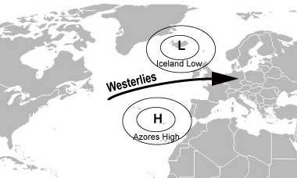

(Positive NAO)

When the situation reverses, called a Negative NAO (high atmospheric pressure over Iceland and low pressure over the Azores) cold air streams over Europe, causing severe cold in the winter. The reduced pressure brings less humidity to Europe; resulting in cold, dry weather devoid of storms as opposed to the more usual winter storms that accompany wetter, milder weather. There are strong indications that during the Little Ice Age the NAO was more often negative.

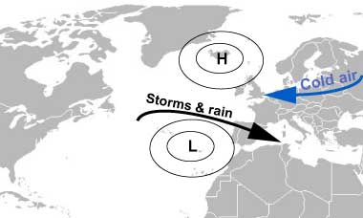

(Negative NAO)

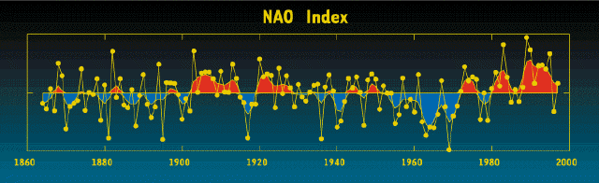

The NAO index is defined as the anomalous difference between the polar low and the subtropical high during the winter season (December through March)

<http://www.eh-resources.org/timeline/timeline_lia.html>

<http://www.ldeo.columbia.edu/res/pi/NAO/>

**Natural Cycles**

In 1999, some paleoceanographers examined sediments of the North Atlantic up to 130,000 years old. They found that every millennium or two sediments like those in the Little Ice Age appear. This suggests that the natural warming and cooling of the earth is on a 1500-year climate cycle. In North America, Greenland, and Iceland debris floats from the North Atlantic and is picked up by the ice, put in icebergs, then sinks when they are melted. During ice ages the amount of debris increases and the scientists found this to happen about every 1500 years. They also noted that the amount of debris and therefore severity of ice ages decreased 10,000 years ago.

Richard A. Kerr. (1999). The Little Ice Age – Only the Latest Big Chill. *Science* Vol 284. No 5423, p. 2069

**The Current Predictions**

According to the Woods Hole Oceanic Institution’s research our current warming global climate trend could end up sending the Earth’s climate into reverse action and into another mini ice age. Using research from past events, scientists have put together a prediction that mimics Milankovitch cycles and Younger Dryas events from previous centuries. They say that our current warming trends, that may or may not be due to increase CO2 levels dispensed into the Earth’s atmosphere, are melting our glaciers, consequently sending large enough amounts of cold dense water into the most unstable ocean conveyor, the North Atlantic Oscillation.

In the science publication, Abrupt Climate Change, scientists don’t know when exactly this ice age could occur, but they predict that if it were to happen, contrary to popular belief, it would happen very rapidly and “chaotically” and not be a slow process at all. Studying ice cores and looking back in time, scientists have seen this rapid cooling before in a period called the quasi period that occurred 1500 years ago.

If this little ice age were to occur. Scientist predicts that due to the disrupted ocean currents the Northern Hemisphere and creating colder climates in those regions/continents. Crops that are not adaptive to cold weather would fail, creating a shortage of production in some agricultural products, like grapes for example

http://www.whoi.edu/page.do?pid=12455&tid=282&cid=10046

[Abrupt Climage Change,” National Academy Press, 2002](http://books.nap.edu/books/0309074347/html/1.html)

**The Effect of the Ice Age on Food Production**

During the Little Ice Age, seasons changed by 15 to 20 percent, over the course of the millennium. During the coldest times of the cycle, the growing period may have been shortened by one to two months. This in turn would have been devastating to farmers with products that needed a full growing season, as well to the world's food chain. During the Little Ice Age, farmers did not have the seeds that we have today that are able to withstand such changes in climate.

The failed harvest of 1693 brought one of the worst famines in the seventeenth century. Millions of people died due to the food shortage in France. In Switzerland, an extended snow covering devastated crops. Livestock also suffered and many were put to death.

The harsh weather took its grip over most of Europe affecting the economy as well. Abandoned farms and little reap of crops, brought smaller state revenue from taxes. The cost of food went up as shown in the following graph.

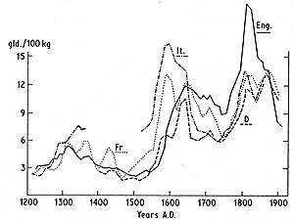

Prices of wheat expressed in Dutch guilders per 100 kg. in various countries vs. time. (Source: Lamb, 1995)

<http://www2.sunysuffolk.edu/mandias/lia/little_ice_age.html>

http://www.grida.no/publications/other/ipcc_tar/?src=/climate/ipcc_tar/wg1/070.htm

**The Crops**

The change in the amount of food production with regarding agriculture relies massively on the length of season and the climate during that period. We are primarily a global entity within agriculture, meaning we are able to out source specific products to regions with preferable growing climates. This means that the devastating impacts of famine are not as prevalent within economically sound states, but those that are not able to out source are still subject to catastrophe, such as, we are seeing in parts of Africa.

Genetically altered crops are able survive in regions all over there earth. Hybrid seeds can be genetically mutated to with stands changes in climate. The main concern in agriculture is water. Without water and sunlight, photosynthesis is not able to occur. Within the last century agriculture has gone from relying on rainfall, to irrigation so we are able to grow foods in dryer climates. NASA is aiding governments and recourse groups by using satellites that revolve around the earth (GRACE), tracking the greenness of an area. (Photosynthesis.) They are also able to examine the earth’s aquifers from space. Aquifers are huge bodies of water under the earth’s crust that most regions of agriculture, use to obtain hydration for irrigation. In the United States the largest aquifer is located under the mid-west, the region where most of our nation’s crops are produced. Aquifers are replenished by the hydrosphere and if there was to be something that disrupted the cycle, the aquifers would deplete at an accelerated speed.

|  |
| --- |
|  |

The image above shows the many processes of the Earth’s hydrologic cycle that contribute to total changes in water storage. Because a large portion of the Earth’s usable fresh water is located in underground aquifers, scientists are interested in determining how groundwater supplies are changing with time. GRACE offers an effective new means of studying the entire water column from space, and will be especially useful for looking at groundwater storage changes. (Image Courtesy NASA GSFC)  
 Ocean, to atmosphere, to land. H>A>L

<http://earthobservatory.nasa.gov/Newsroom/NasaNews/Agriculture2009/>

<http://earthobservatory.nasa.gov/Features/WeighingWater/weighing2.php>

<http://www.atmos.washington.edu/1998Q4/211/project2/group4.htm>

Within this research of the NAO we can see how the oceanic oscillations also affect the climate and in turn affect crop productivity. The human variable can alter crops genetically, but halting a major change to climate due to irregular oscillations is impossible. A change to the NAO oscillations and a reduction in sunspots can change the growing season so much that food productivity would be threatened. A possible solution could be to grow the more fragile plants in greenhouses, where humans have full control.

**Analysis of the Effect of the Little Ice Age on the Different Spheres**

**E>A:** The atmosphere cooled and froze large bodies of water creating a land event of the little ice age. Decreased sunlight coming through, Surface Albedo

**E>H**: The hydrosphere also cooled during the little ice age, freezing large bodies of water (including some that don’t normally freeze) creating glaciers, and expanding the poles.

**E>L**: Froze the land, volcanoes

**E>B**: Cool temps killed off crops, vegetation, and increased diseases, animals died off due to lack of available food sources, animal migration patterns changed

**E>A>H:** Initial warming, glaciers melted and went into the ocean disrupting The North Atlantic oscillation to initially change, creating colder waters

**E>H>A:** North Atlantic oscillation changed around Europe creating cold air over the continent

**E>A>H>L>B:** The warming of the air caused the melting of the glaciers, which changed the NAO, which then sent cold air unto the European land. The land then froze consequently affected the vegetation (killing it off), and creating scarce food sources for the animals in that region. They eventually died off.

**L>A>E:** Volcanic Eruption (ex. Tambora 1815) sent sulfur dioxide into the air causing less sun to penetrate and did increase the cooling of the earth (The Year Without the Summer)

1. **List what is unknown**

* Why did the volcano activity increase during this period?
* What causes the natural cycle of climate changes about every 1,500 years?

1. **List what needs to be done**
2. **Develop a problem statement**

We are trying to analyze where funds should go for producing the worlds crops based on past and current climate records. We will be using the little ice age as a model for researching this issue.

1. **Gather information (Ideas, possible solutions, and pros and cons of potential courses of action)**
2. **Present findings (Recommendations and Predictions)**